Agile SRS

ECE VR Self-Regulation

**Shawn Coverini**

**Date: 2018-12-13**

**Revision: 2**

# Revision

|  |  |  |  |
| --- | --- | --- | --- |
| Rev | Date | Description | By |
| 1 | 2018-12-10 | Create Document | Shawn Coverini |
| 2 | 2018-12-13 | Add UC Diagrams  Add UI  Add Reliability | Shawn Coverini |

Table of Contents

Revision 2

Tables 4

1 Introduction 5

1.1 Purpose 5

1.1.1 List of Target Customers 5

1.2 Scope 5

1.3 Definitions, Acronyms and Abbreviations 5

1.4 References 6

1.5 Overview 7

2 Overall Description 7

2.1 Product Perspective 7

2.1.1 System Interfaces 8

2.1.2 User Interfaces 9

2.1.3 Hardware Interfaces 11

2.1.4 Software Interfaces 11

2.1.5 Operations 11

2.1.6 Site Adaptation Requirements 11

2.2 Product Functions 13

2.2.1 NPC Interaction 13

2.2.2 Watson Interaction 14

2.2.3 Analyze Feedback 15

2.3 User Characteristics 15

2.4 Constraints 16

2.5 Assumptions and Dependencies 16

2.6 Apportioning of Requirements 16

2.7 Software System Attributes 16

2.7.1 Reliability 16

2.7.2 Availability 16

2.7.3 Security 16

2.7.4 Maintainability 17

2.7.5 Portability 17

# Tables

Table 1Competitors 8

Table 2Requirements 12

# 1 Introduction

## 1.1 Purpose

The main purpose of this document is to layout and design the ECE VR Self-Regulation Simulator. There are multiple groups involved in early childhood education and each would be a potential market. It may even be possible to direct the focus towards parents to help teach them how help their own children with self-regulation.

### 1.1.1 List of Target Customers

* Directors, managers, and supervisors of child organizations
  + Private
  + Non-profit
* Post secondary institutes
* Municipalities and Regions
  + Home licensed care
  + Regional child care
* Parents

## Scope

The ECE VR Self-Regulation Simulator will include, VR simulation, voice interactivity, track user progression, analyze user interactions, and have limited use of IBM Watson. The ECE VR Self-Regulation Simulator will not include a way to improve user performance. Overall, it will be a prototype simulation for helping users practice implementing skills in order to help children with Self Regulation

Several goals will have to be met for ECE VR Self-Regulation Simulator. The major ones being:

* Implementation of simulations (1-3)
* Implement native speech recognition for simulation interaction
* Convert Speech-to-Text
* Get feedback from Watson Natural Language Understanding
* Get feedback from Watson Tone Analyzer
* Get feedback from Watson Personality Insight
* Develop Inference from feedback

(Coverini, Project Charter: ECE Self Regulation, 2018)

The benefits of using this product would be to better prepare users for helping children learn self-regulation by exposing the user real life scenarios without using the children they are supposed to be teaching as a teaching tool.

## 1.3 Definitions, Acronyms and Abbreviations

|  |  |
| --- | --- |
| Word | Definition |
| VR | Virtual Reality |
| ECE | Early Childhood Education |
| Self-Regulation | Ability to focus and control a person’s emotions, feelings, and behaviors |

## 1.4 References

Clark, S. (2013). *SET Guidelines for Documenting Requirements in an Agile Way.* Kitchener: Conestoga College.

Corperation, M. (2018, March 20). *Gaze targeting*. Retrieved from Microsoft Dev Center: https://docs.microsoft.com/en-us/windows/mixed-reality/gaze-targeting

Coverini, S. (2018). *Preliminary Investigation Report: ECE Self Regulation.* Kitchener: Shawn Coverini.

Coverini, S. (2018). *Preliminary Scope.* Kitchener: Shawn Coverini.

Coverini, S. (2018). *Project Charter: ECE Self Regulation.* Kitchener: Shawn Coverini.

Microsoft Corperation. (2018, March 20). *Interactable object*. Retrieved from Windows Dev Center: https://docs.microsoft.com/en-us/windows/mixed-reality/interactable-object

Microsoft Corporation. (2017, 09 12). *Minimum PC hardware guidelines*. Retrieved from Windows Dev Center: https://docs.microsoft.com/en-us/windows/mixed-reality/enthusiast-guide/windows-mixed-reality-minimum-pc-hardware-compatibility-guidelines

Park, D. Y. (2018, May 10). *Open-Source Building Blocks for Windows Mixed Reality Experiences*. Retrieved from Medium: https://medium.com/@dongyoonpark/open-source-building-blocks-for-windows-mixed-reality-experiences-hololens-mixedrealitytoolkit-28a0a16ebb61

The Institute of Electrical and Electronics Engineers, Inc. (1998). *IEEE Recommended Practice for Software Requirements Specifcations.* New York: The Institute of Electrical and Electronics Engineers, Inc.

TLE TeachLivE. (2018, November 2). *TeachLivE*. Retrieved from Articles: http://teachlive.org/media/articles/

TLE TeachLivE. (2018, November 2). *TLE TeachLivE*. Retrieved from TeachLive: http://teachlive.org/

## 1.5 Overview

From this point the SRS breaks down in to an overview and specifics of the systems designs, features, constraints and assumptions.

The SRS from this point is broken down into the following sections:

* Overall Description
  + Product Perspective
    - System Interfaces
    - User Interfaces
    - Hardware Interfaces
    - Software Interfaces
    - Operations
    - Site Adaptation Requirements
  + Product Functions
  + User Characteristics
  + Constraints
  + Assumptions and Dependencies
  + Apportioning of Requirements
  + Software System Attributes

# 2 Overall Description

## 2.1 Product Perspective

Being able to effectively help the child learn to properly self-regulate their emotions is very important to the child’s development. While theory is taught to new educators there is nothing available to help translate the theory into practice. Even for parents and other adults there is no easy way to practice teaching children Self-Regulation skills without learning on the children. ECE VR Self-Regulation Simulator aims to help bridge that gap by placing users into a virtual environment where they will be able to practice the theory by simulating its use and get feedback to improve. Or for further instructor feedback if being used by educators.

Each simulation will place the user into several scripted scenarios where their capacity to properly coach children in self-regulation will be analyzed. Users will be able to talk to different children NPC with voice recognition. When they user gives an appropriate set of responses the simulation will end, and they will be rated. The higher the rating the more effectively they used the tools they were taught. To help the educator, the system will analyze what the user had said for further reflection. Once the user has completed a simulation, they will be given the opportunity to move on to the next one that is available.

Table 1Competitors

|  |  |
| --- | --- |
| Competitor | Description |
| TeachLive | Developed at the University of Central Florida is being used at 85 campuses in the United States. The software is meant to be used to allow teachers to learn new skills without having actual students take the risk on being taught with a new or unproven skill. (TLE TeachLivE, 2018) |
| Virtual Classroom Ericsson | Even less information on this application can be found then in the case of TeachLive except for some references to the product in articles online about brining mobile solutions to education in developing nations, the application is only really referenced on the site of the studio that built it with Ericsson.  Immersive Studios mostly just has a landing page showing a basic overview of the application and what features it is supposed to have but no link to specific examples, or product pages, or purchase options. |

(Coverini, Preliminary Investigation Report: ECE Self Regulation, 2018)

### 2.1.1 System Interfaces

ECE VR Self-Regulation Simulator will interact with either Cortana or Watson Speech to Text depending on usage limitations

### 2.1.2 User Interfaces

The user interface will use UI elements in the windows mixed reality toolkit in order to maintain a consistent design pattern with windows.

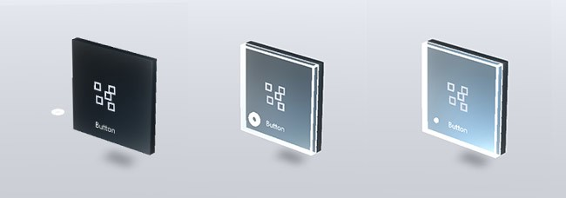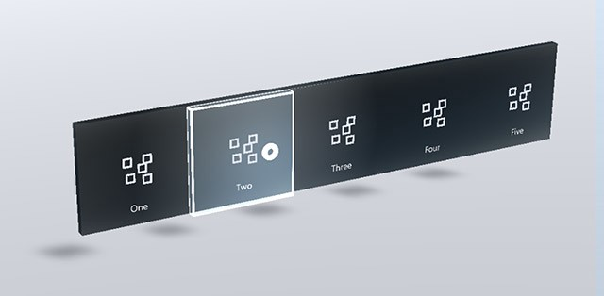

(Park, 2018)

Intractable UI objects such as buttons, switches and dialogues are all provided.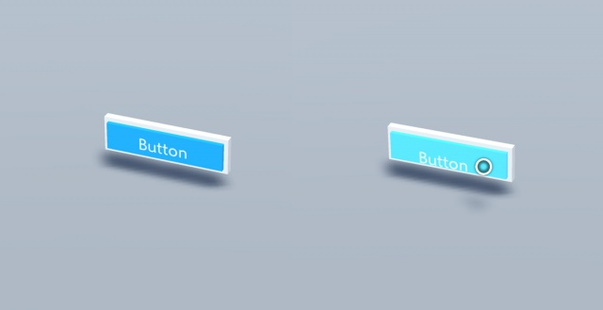

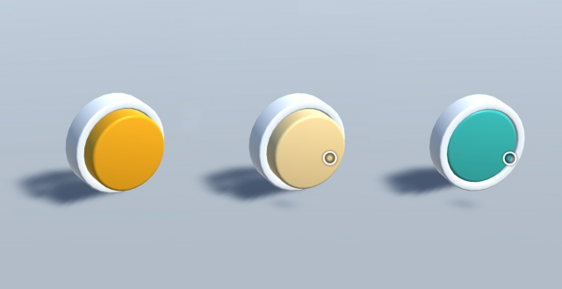

(Microsoft Corperation, 2018)

Objects that can interact with the gaze functionality will also use the standard shaders provided by the MRTK for Unity.

(Corperation, 2018)

### 2.1.3 Hardware Interfaces

ECE VR Self-Regulation Simulator will be using the Windows Mixed Reality Headset in order to run a VR Simulation.

### 2.1.4 Software Interfaces

* Microsoft Mixed Reality Toolkit
* Unity
* Watson Speech-To-Text
* Watson Natural Language Understanding
* Watson Tone Analyzer
* Watson Personality Insight

(Coverini, Preliminary Investigation Report: ECE Self Regulation, 2018)

### 2.1.5 Operations

ECE VR Self-Regulation Simulator will have two modes of operation:

1. Simulation: Run the simulation for a user.
2. Analyze: Collect and show previous data from users

### 2.1.6 Site Adaptation Requirements

In order to run ECE VR Self-Regulation Simulator a laptop or desktop will be needed that can run the requirements of Windows Mixed Reality listed below along with a supported Window Mixed Reality Headset.

Table 2Requirements

|  |  |  |
| --- | --- | --- |
|  | Windows Mixed Reality Ultra PCs | Windows Mixed Reality PCs |
| Operating System | Windows 10 Fall Creators Update (RS3) - Home, Pro, Business, Education. (**Note**: Not supported on N versions or Windows 10 Pro in S Mode) | |
| Processor | Intel Core i5 4590 (4th generation), quad-core (or better)  AMD Ryzen 5 1400 3.4Ghz (desktop), quad-core (or better) | Intel Core i5 7200U (7th generation mobile), dual-core with Intel® Hyper-Threading Technology enabled (or better) |
| RAM | 8GB DDR3 (or better) | 8GB DDR3 dual channel (or better) |
| Free disk space | At least 10 GB | |
| Graphics Card | * NVIDIA GTX 1060 (or greater) DX12-capable discrete GPU * AMD RX 470/570 (or greater) DX12-capable discrete GPU **Note:** GPU must be hosted in a PCIe 3.0 x4+ Link slot | * Integrated Intel® HD Graphics 620 (or greater) DX12-capable integrated GPU [(check if your model is greater)](https://en.wikipedia.org/wiki/List_of_Intel_graphics_processing_units) * NVIDIA MX150 (or greater) discrete GPU * 965M (or greater) DX12-capable discrete GPU * AMD Radeon RX 460/560 |
| Graphics Driver | Windows Display Driver Model (WDDM) 2.2 | Windows Display Driver Model (WDDM) 2.2 |
| [Graphics display port](https://docs.microsoft.com/en-us/windows/mixed-reality/enthusiast-guide/recommended-adapters-for-windows-mixed-reality-capable-pcs) | HDMI 2.0 or DisplayPort 1.2 | HDMI 1.4 or DisplayPort 1.2 |
| Display | Connected external or integrated VGA (800x600) display (or better) | |
| [USB connectivity](https://docs.microsoft.com/en-us/windows/mixed-reality/enthusiast-guide/recommended-adapters-for-windows-mixed-reality-capable-pcs) | USB 3.0 Type-A or Type-C | |
| Bluetooth connectivity (for [motion controllers](https://docs.microsoft.com/en-us/windows/mixed-reality/enthusiast-guide/motion-controllers)) | Bluetooth 4.0 | |
| Expected headset framerate | 90 Hz | 60 Hz |

(Microsoft Corporation, 2017)

## 2.2 Product Functions

* Simulate Interactions between user and child NPC for teach Self-Regulation
* Recognize speech of user for interaction with NPC
* Convert user speech to text
* Get feedback from Watson Natural Language Understanding, Watson Tone Analyzer, and Watson Personality Insight
* Develop Inference from feedback

### 2.2.1 NPC Interaction



|  |
| --- |
| NPC Interaction |
| The user will be able to interact with an NPC by using the controllers. If the input is valid the NPC will run the appropriate response and the result of the interaction will be saved by the system for analysis at the end of the simulation. The user will also be able to send voice commands to the PhraseRecognitionSystem that will match the voice command a send the appropriate action to the NPC. |

### 2.2.2 Watson Interaction



|  |
| --- |
| Watson Interaction |
| The user will also be able to send voice commands to the PhraseRecognitionSystem that will then convert the speech to text and send it of to Several Watson APIs for analysis. The system will the store the data for analysis at the end of the simulation |

### 2.2.3 Analyze Feedback



|  |
| --- |
| Analyze Feedback |
| At the end of the simulation the system will collect data from the different levels that was recorded, analyze and score the results of the data and combine that information with the different analysis produce by Watson in ordered to present a final report to the user of how they performed. |

## 2.3 User Characteristics

The user that the application will be focused towards are teachers, students and early childhood educators. Users will be those who lack experience in the feel or who need to update their knowledge to more modern standards. Currently, there is no data looking at the technological literacy of the ECE industry. While most users will have, or be working towards, at least a college diploma through conversations with Harmony there is an anecdotal evidence that technical skills might be limited for setting up the application for proper use. This possibility will have to be considered along with the knowledge that it is most likely the purchasers of the program will be large institutions that could provide training to members of the ECE industry.

## 2.4 Constraints

Several constraints can limit the project:

1. Cost of hard ware to run the application ranges between 1400$ and 2500$ for a computer and a Mixed Reality Headset.
2. Limits on the free tier of Watson could limit initial growth or even testing of the application.
3. Unity Pro would cost up to 125$ per month per user along with 45$ per month for Visual Studio (800$-1200$ for purchase and upgrades)
4. Currently the only developer is Shawn Coveini with advice from Harmony Simard, Russell Foubert, and potentially a research grad, along with the VR Lab
5. Finally, legislation involving processing and storing of student data could also be a problem for the application

## 2.5 Assumptions and Dependencies

* VR Lab Laptop will remain available
* Acer Windows Mixed Reality Headset will remain available
* IBM Will maintain free tiers for Watson Services
* Watson will be able to provide usable feedback from user game interaction

(Coverini, Preliminary Scope, 2018)

## 2.6 Apportioning of Requirements

Nothing currently

## 2.7 Software System Attributes

### 2.7.1 Reliability

* Implementation of simulations (1-3)
* Implement native speech recognition for simulation interaction
* Convert Speech-to-Text
* Get feedback from Watson Natural Language Understanding
* Get feedback from Watson Tone Analyzer
* Get feedback from Watson Personality Insight
* Develop Inference from feedback

### 2.7.2 Availability

The system will need an internet connection in order to have proper access to voice recognition and Watsons analytical APIs, along with access to a Windows Mixed Reality Headset, Microphone, and computer that meets the requirements in Table 2.

### 2.7.3 Security

Data connection between Watson and the application will have to be protected (possibly through SSL).

### 2.7.4 Maintainability

Windows Mixed Reality Toolkit and Unity have compatibility issues between newer and different versions of each making extra difficulty in maintaining the code.

### 2.7.5 Portability

* Windows Mixed Reality limits the use of the host OS
* The OS will be Windows 10
* Estimated 5% of code will be dependant on Windows
* C# and Unity is portable to all major OS
* Watson services are independent from Windows (including text to speech)